
Company
Logotype

Cone Beam Computed Tomography- Report



Porur Dental X-rays & CBCT

Patient Name : Mrs. Vanaja | Date of Report : 27.06.2024
Age/ Gender : 40 years/ Female | Region of Interest : CBCT Sectional Mandible
Referring doctor: Dr. Karthik | Indication : Implant assessment
Clinical Notes: Nil
PATIENT INFORMATION

CBCT- Sectional Mandible provided
CBCT – IMAGE DETAILS

RADIOGRAPHIC INTERPRETATION

- Complete loss of crown and root structure in relation to 36.
- The alveolar bone in relation to 36 is present with normal trabecular pattern.
- In relation to 37, presence of a hyperdense restorative material involving the crown in evident.

IMPLANT ASSESSMENT

 | 36 region | 37 region
Sub-Crestal (in mm) | 6.87 | 8.52
Mid- Crestal (in mm) | 7.8 | 9.2
Distance between alveolar ridge and the inferior alveolar nerve canal (in mm) | 12.96 | 14.63
Distance between alveolar ridge and the inferior border of mandible (in mm) | 23.44 | 23.19

RADIOGRAPHIC IMPRESSION

- Partially edentulous region: 36.
- Restored tooth: 37.

Kindly correlate with clinical findings


IMAGES FOR REFERENCE

RECONSTRUCTED PANORAMIC VIEW
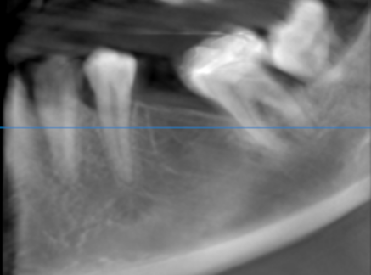

3-DIMENSIONAL VIEW
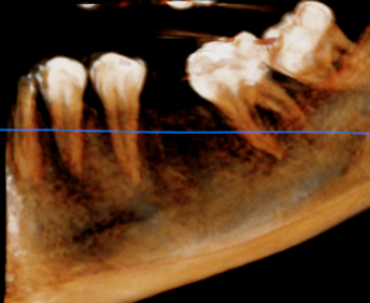

CROSS SECTIONAL VIEW

36 region | 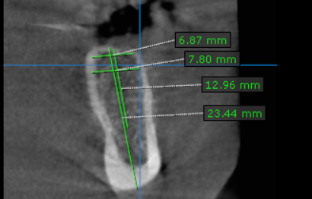
37 region | 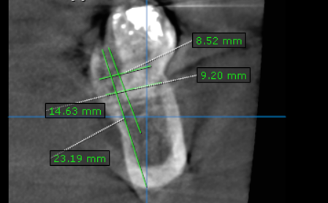V

**** End of report ****

